**DSP Experiment 11 Output**

**Digital Butterworth Using Bilinear Transformation**

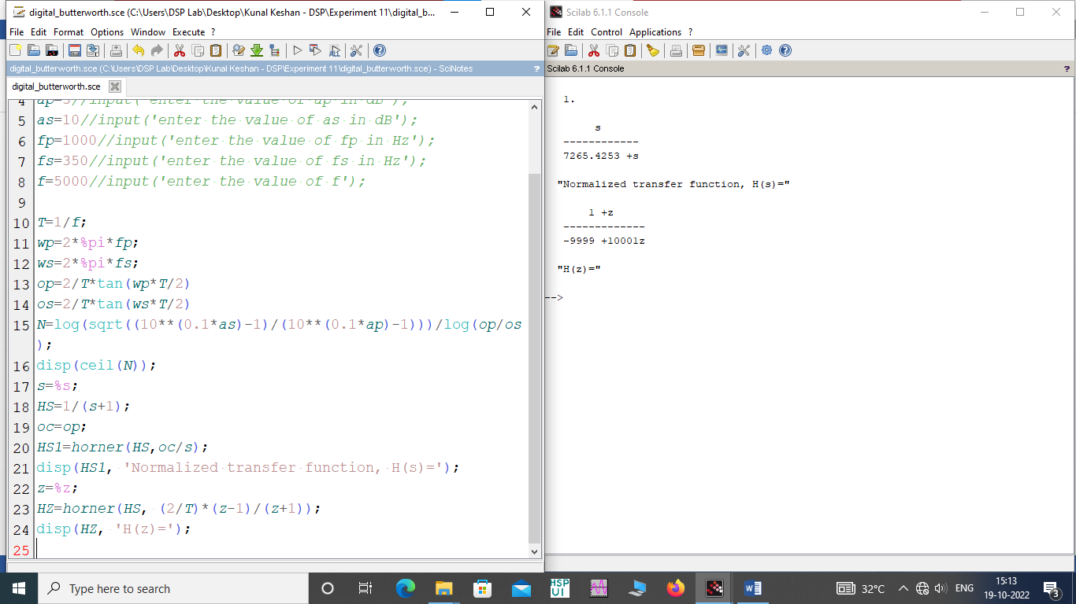

**Digital Butterworth Using Impulse Invariant Method**

